# 3.3 Arithmetic on Vectors in 3-Dimensional Space

## ADDITION & SUBTRACTION OF VECTORS

To add or subtract two vectors, add or subtract their corresponding components.

To **add** the vectors $\vec{u}=\left\langle 2, 5, \left.4 \right\rangle \right.$ and $\vec{v}=\left\langle 4,\left.2,1\right\rangle \right.,$ add their corresponding components.

Example (1)

$\vec{u} + \vec{v}=\left\langle 2+4,\left.5+2, 4+1\right\rangle \right.= \left\langle 6,\left.7, 5\right\rangle \right.$

So, $\vec{u} + \vec{v}=\left\langle 6,\left.7, 5\right\rangle \right.$

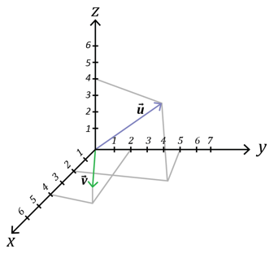

Now, graph this sum. Start at the origin.

Since the $x-$ component is 6, move 6 units in the $x-$ direction.

Since the $y-$ component is $7$, move 7 units in the $y-$ direction.

Since the $z-$ component is $5$, move 5 units upward.

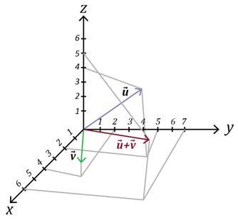

To **subtract** the vectors $\vec{u}=\left\langle 2, 5, \left.4\right\rangle \right.$ and $\vec{v}=\left\langle 4,\left.2, 1\right\rangle \right.$ subtract their corresponding components.

Example (2)

$$\vec{u}- \vec{v}=\left\langle 2-4,\left.5-2, 4-1\right\rangle \right.= \left\langle -2,\left.3, 3\right\rangle \right.$$

So, $\vec{u}- \vec{v}=\left\langle -2,\left.3, 3\right\rangle \right.$

## SCALAR MULTIPLICATION

Scalar multiplication is the multiplication of a vector by a real number (a scalar).

Suppose we let the letter $k$ represent a real number and $\vec{v}$ be the vector $\left\langle x\right.,\left.y,z\right\rangle .$ Then, the scalar multiple of the vector $\vec{v}$ is

$$k\vec{v}=\left\langle kx\right.,\left.ky,kz\right\rangle$$

Suppose $\vec{u}=\left\langle -3,\left.-8, 5\right\rangle \right.$ and $k=3$.

Example (1)

Then $k\vec{u}=$ 3 $\vec{u}=3\left\langle -3,\left.-8, 5\right\rangle \right.= \left\langle 3(-3),\left.3\left(-8\right),3(5)\right\rangle \right.=\left\langle -9,\left.-24, 15\right\rangle \right.$

Suppose $\vec{v}=\left\langle 6,\left.3,-12\right\rangle \right.$ and $k=\frac{-1}{3}$.

Example (2)

Then $k\vec{u}=$ $\frac{-1}{3}\vec{u}=\frac{-1}{3}\left\langle 6,\left.3, -12\right\rangle \right.= \left\langle \frac{-1}{3}(6),\left.\frac{-1}{3}\left(3\right),\frac{-1}{3}(-12)\right\rangle \right.=\left\langle -2,\left.-1, 4\right\rangle \right.$

Suppose $\vec{u}=\left[\begin{aligned}\begin{matrix}-2 \\ 6\end{matrix} \\ 0\end{aligned}\right]$, $\vec{v}=\left[\begin{matrix}1 \\ 2 \\ -8\end{matrix}\right]$, and $\vec{w}=\left[\begin{matrix}-3 \\ -1 \\ 2\end{matrix}\right]$. Find $3\vec{u}+4\vec{v}-2w.$

Example (3)

Then $3\vec{u}+4\vec{v}-2w=3\left[\begin{aligned}\begin{matrix}-2 \\ 6\end{matrix} \\ 0\end{aligned}\right]+4\left[\begin{matrix}1 \\ 2 \\ -8\end{matrix}\right]-2\left[\begin{matrix}-3 \\ -1 \\ 2\end{matrix}\right]=\left[\begin{aligned}\begin{matrix}-6 \\ 18\end{matrix} \\ 0\end{aligned}\right]+\left[\begin{matrix}4 \\ 8 \\ -32\end{matrix}\right]+\left[\begin{matrix}6 \\ 2 \\ -4\end{matrix}\right]=\left[\begin{matrix}4 \\ 28 \\ -36\end{matrix}\right]$

## USING TECHNOLOGY

We can use technology to determine the value of adding or subtracting vectors.

Go to www.wolframalpha.com.

Suppose and $\vec{u}=\left[\begin{aligned}\begin{matrix}-2 \\ 6\end{matrix} \\ 0\end{aligned}\right]$, $\vec{v}=\left[\begin{matrix}1 \\ 2 \\ -8\end{matrix}\right]$, and $\vec{w}=\left[\begin{matrix}-3 \\ -1 \\ 2\end{matrix}\right]$. Use WolframAlpha to find $3\vec{u}+4\vec{v}-2w.$ In the entry field enter evaluate 3*[-2,6,0] + 4*[1,2,-8] – 2*[-3,-1,2].

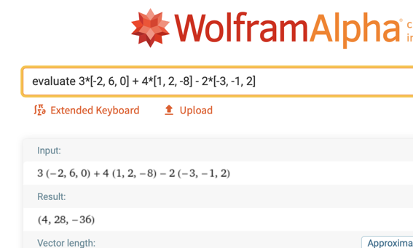

WolframAlpha answers $(4, 28, -36)$ which is WolframAlpha’s notation for $\left[\begin{matrix}4 \\ 28 \\ -36\end{matrix}\right]$.

## EXAMPLES

1. Add the vectors $\vec{u}=\left\langle -3,\left.4, 6\right\rangle \right. and\vec{ v}=\left\langle 8,\left.7,-5\right\rangle \right..$

ANS: $\vec{u} + \vec{v}=\left\langle 5,\left.11, 1\right\rangle \right.$

1. Subtract the vector $\vec{v}=\left\langle 8,\left.7,-5\right\rangle \right.$ from the vector $\vec{u}=\left\langle -3,\left.4,6\right\rangle \right..$

ANS: $\vec{u}- \vec{v}=\left\langle -11,\left.-3, 11\right\rangle \right.$

1. Given the three vectors, $\vec{u}=\left\langle 2,\left.4,-5\right\rangle \right.$, $\vec{ v}=\left\langle -3,\left.4, -8\right\rangle \right.$, and $\vec{w}=\left\langle 0,\left.1, 2\right\rangle \right.$,  
   find $2\vec{u}+3\vec{v}-4\vec{w}$.

ANS: $2\vec{u}+3\vec{v}-4\vec{w} =\left\langle -5,\left.16, -42\right\rangle \right.$

1. Suppose and $\vec{u}=\left[\begin{matrix}3 \\ 4 \\ -2\end{matrix}\right]$, $\vec{v}=\left[\begin{matrix}-1 \\ 6 \\ 4\end{matrix}\right]$, and $\vec{w}=\left[\begin{matrix}0 \\ 5 \\ 2\end{matrix}\right]$, find $4\vec{u}-4\vec{v}-\vec{w}$.

ANS: $4\vec{u}-4\vec{v}-\vec{w}=\left\langle 16,\left.-13, -26\right\rangle \right.$

## NOTE TO INSTRUCTOR

Consider working through these examples.

1. Add the vectors $\vec{u}=\left\langle 3,\left.-4, 5\right\rangle \right. and \vec{v}=\left\langle -1,\left.4, 2\right\rangle \right..$

ANS: $\vec{u} + \vec{v}=\left\langle 2,\left.0, 7\right\rangle \right.$

1. Subtract the vector $\vec{v}=\left\langle -5,\left.2, 1\right\rangle \right.$ from the vector $\vec{u}=\left\langle -9,\left.4,-3\right\rangle \right.$.

ANS: $\vec{u}- \vec{v}=\left\langle -4,\left.2,-4\right\rangle \right.$

1. Given the three vectors, $\vec{u}=\left\langle 1,\left.-2,-3\right\rangle \right.$, $\vec{ v}=\left\langle 4,\left.3, 2\right\rangle \right.$, and $\vec{w}=\left\langle 1,\left.-1, 1\right\rangle \right.$,  
   a. Find $2\vec{u}+3\vec{v}-4\vec{w}$.  
   b. Find the length of the vector $2\vec{u}+3\vec{v}-4\vec{w}$.

ANS: a. $2\vec{u}+3\vec{v}-4\vec{w}$ = $\left\langle 10,\left.9, -4\right\rangle \right.$  
 b. $\sqrt{197}$

1. Suppose and $\vec{u}=\left[\begin{aligned}1 \\ 1 \\ -3\end{aligned}\right]$, $\vec{v}=\left[\begin{aligned}-5 \\ 2 \\ 6\end{aligned}\right]$, and $\vec{w}=\left[\begin{aligned}6 \\ 0 \\ -6\end{aligned}\right]$, find $3\vec{u}-4\vec{v}-2\vec{w}.$

ANS:

[3-3_arithmetic_on_vectors_in_3-dimensional_space.docx](https://oer4cte.org/math4gamedevelopers/teacher/3-3_arithmetic_on_vectors_in_3-dimensional_space.docx), attributed to Denny Burzynski (author) and Downey Unified School District (publisher) is licensed under CC BY-NC 4.0. To view a copy of this license, visit https://creativecommons.org/licenses/by-nc/4.0